Standard | Items:
5.OA.01  Use parentheses, brackets, or braces in numerical expressions, and evaluate expressions with these symbols. | 3.0  1A. If you were solving this expression, what would be your first step?  24 - (2 + 6)  - 24 - 2  - 2 - 6  - 2 + 6  - 24 + 6  1B. Evaluate this expression.  24 - (2 + 6)
2.0

1. Evaluate this expression.

10 x (3 + 5)

2. If you were solving this expression, what would be your first step?

16 - (8 ÷ 4)

- 16 - 8
- 8 ÷ 4
- 16 - 4
- 16 - 12

5.MD.05b  Apply the formulas V=l×w×h and V=b×h for rectangular prisms to find volumes of right rectangular prisms with whole- number edge lengths in the context of solving real world and mathematical problems. | 3.0  Base = 100 ft. sq.  12 ft  [Real World Context Base x H]  A. Mr. Smith is building a shed in his backyard with a base of 100 ft. sq. and a height of 12ft. What is the volume of his shed?  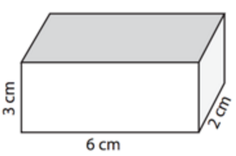  [Real World Context L x W x H]  B. Mrs. Green is buying a jewelry box with a length of 6 cm, a width of 2 cm, and height of 3 cm. What is the volume of her jewelry box?  10 m  4 m  8 m  4 m  [Whole number L x W x H]  C. Find the volume of the rectangular prism above.  Base = 12 cm. sq.  6 cm  [Whole number Base x H]  D. Find the volume of the rectangular prism above.
2.0
[Whole number L x W x H]
- Find the volume of the rectangular prism below:
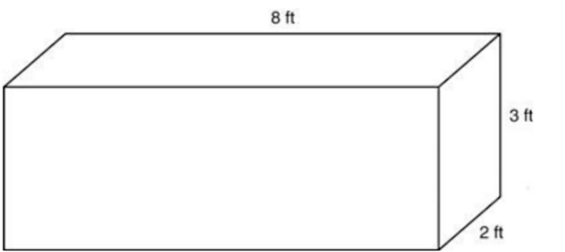

[Whole number Base x H]

2. Find the volume of the rectangular prism below.
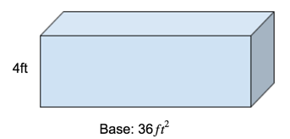

5.MD.05c  Recognize volume as additive. Find volumes of solid figures composed of two non-overlapping right rectangular prisms by adding the volumes of the non-overlapping parts, applying this technique to solve real world problems. | 3.0 The figure below shows two delivery boxes. Find the combined volume of both boxes.  [Real World Context L x W x H]  6 in.  4 in.  3 in.  12 in.  7 in.  10 in.  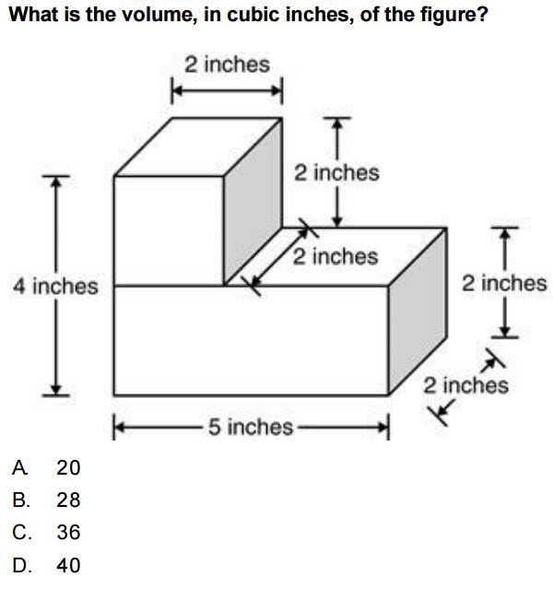
2.0
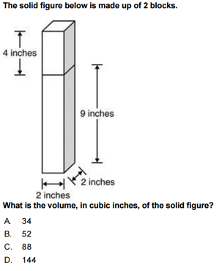
5.NBT.05  Fluently multiply multi-digit whole numbers using the US Standard Algorithm. | 3.0  Solve the following problem using the US Standard Algorithm.  67 x 89 = ?
2.0
- 2a Solve the following problem using any strategy.

34 x 72 = ?

- 2b Solve the following problem using the standard algorithm.
3604 x 5 = ?

Bi-level Analysis

BI-LEVEL ANALYSIS

